



EMM6

Laser Device data Integration Test Process

From Javra Software B.V.

Date: 9 december 2015

Version: 1.0

1. **Introduction:**

This document covers all the details about what we will do during test session of laser device data integration which is scheduled for Friday at 9:15 CET at Dutch time.

1. Data Integration Process

Here we mention all the process of data integration and the responsibilities of Euro-Mit (Client side) and our (Javra side) as well.

**Euro-Mit:**

Euro-Mit will place the sample steel below to the laser device and then press “start storage” from the laser navigator screen (If all setup is okay, I guess Mr. Oudhoff did these stuffs). After that laser device head moves from start point and measured the steel to the end point, while finished click on “stop storage” button.

For Step wise details, please have a look on images.

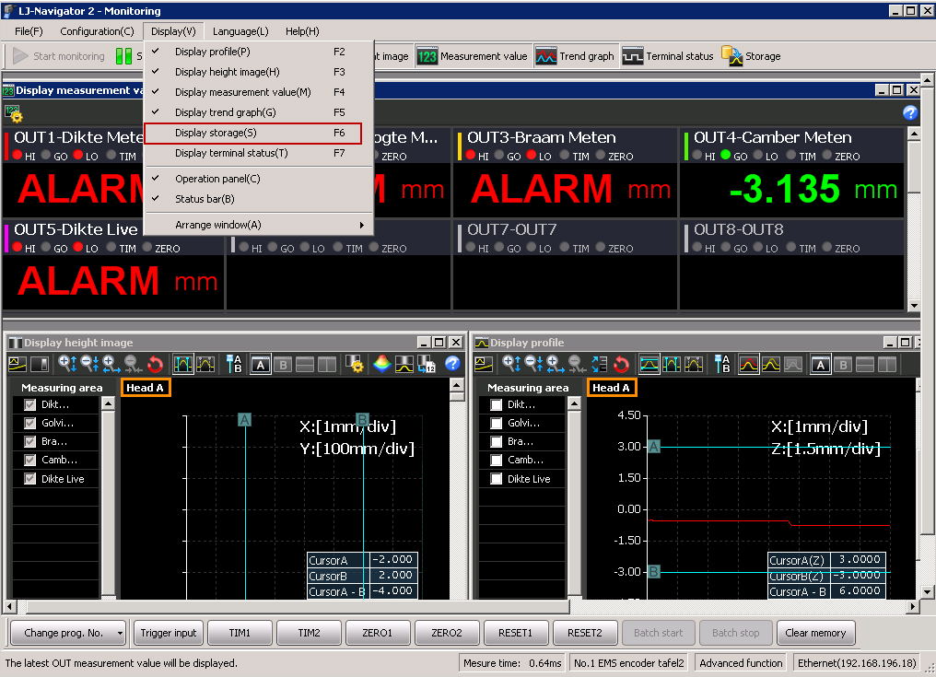

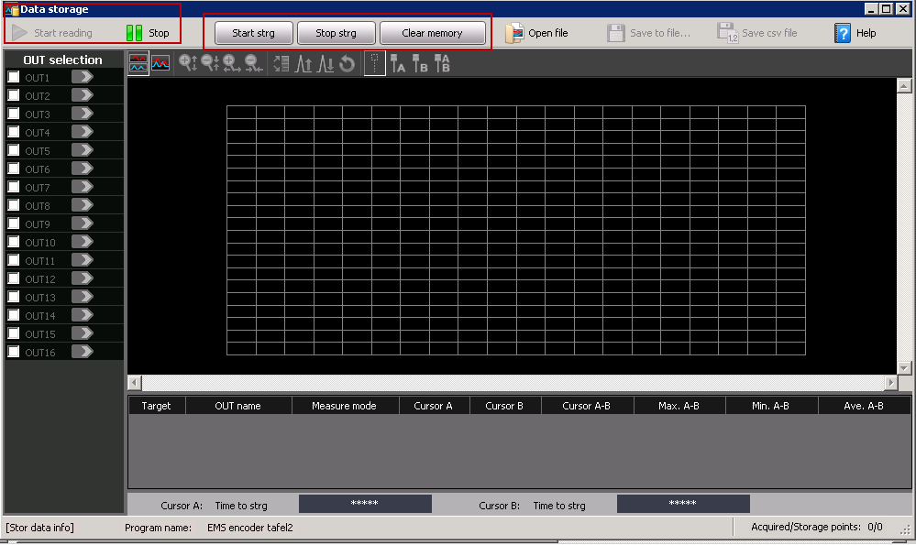

After “Start Storage” Data Storage Screen should be look like this

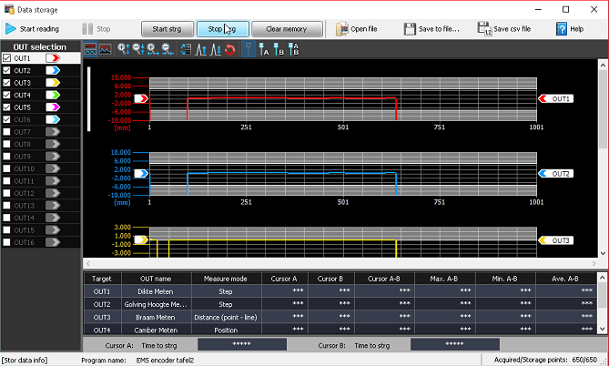

**Note: I’m not sure what other settings should you do (which was done by Keyence representative Mr. Oudhoff). But above this is the basic things that Euro-mit should always do with laser navigator while measurement.**

**But in future we can add start and stop storage buttons in the ems system.**

**Javra Site**

**For Batch Files:**

For batch value process, we made toolbar buttons in our local ems system (You will found in the below image). Using “Get Storage” (green icons) button, we will get the storage data from the laser controller and this data will be save in the specified location with .txt or .csv file extension (location are also adjusted dynamically from the extra setting). After finished save process, we will fetch data from the location then analyze it in the ems system and store maximum value in the specified fields (task manager measure, slit tab).

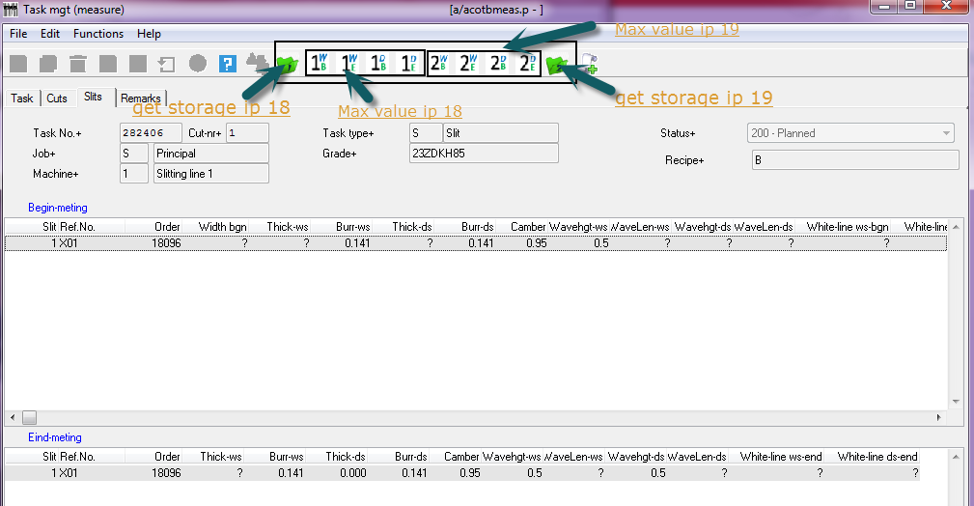

**Thickness:**

For thickness, we will use same 4 tools bar buttons which was normally used to store maximum value. Thickness will be fetch using “get measurement value” method. This method fetches the data from the laser navigator screen and stores in the ems table inside specified field. It should be done always one at a time.

**Eg:**



**Begin-meting**

1wb: thick-ws

1db: thick-ds

**Eind-Meting**

1we: thick-ws

1de: thick-ds

**Note: thickness can measured before “get storage data” (click event) or after stored maximum value.**

**Question:** I**s it possible to store batch file value and thick from same button?**

**Answer: Yes we made some logic that provide us this facility. But after click on “get storage” button you cannot fetch thickness instead of maximum value from batch.**

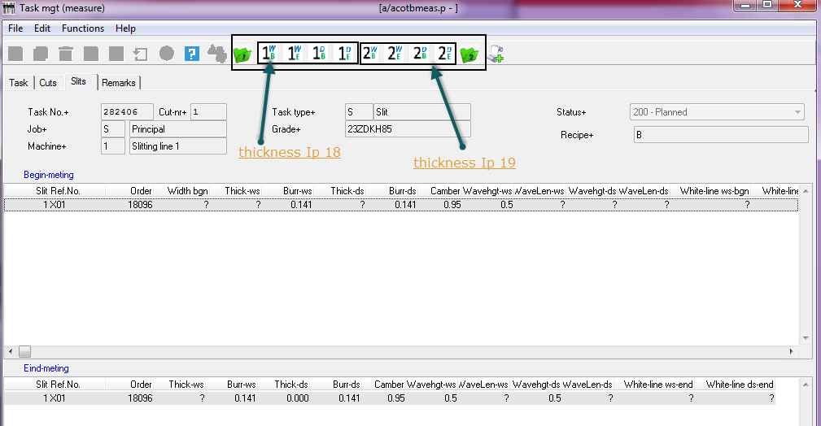

**For Validation:**

We also include validation logic in the ems system. During testing will comment this logic because we should ensure that whether ems fetch maximum value or not. If we have a time, we will check validation also.

Output 2: Waviness,

h**e**ight must be < 3 mm

Factor must be below 1,5% [wave height in mm / wave length in mm) * 100%]

Output 3: Burr,

90-% > max 0,010 mm **( Okay we can do that while doing valiedation of the data)**

10% -> max 0,020 mm **( Okay we can do that while doing valiedation of the data)**

Output 4: Camber

Width < 250 mm -> must be < 0,5 mm

Width > 250 mm -> must be < 0,2 mm

**Note: Factor not be calculated because of the absence of wave length in the system.**